Student name: Christopher Kai Tannock

Date of submission: 12th, January,2020

Course: Introduction to Energy Science

Professor: Koji Segawa, Mayumi Matsumoto

Energy Strategy for Remote Japanese Cities: Vision to Achieve both Social and Ecological Resilience

Introduction

Ecological and social resilience are particularly important in the age of climate change and globalization. This is because not only the number of natural disasters will likely to increase by climate change, the impact which faraway regions would bring to the other region has increased dramatically due to globalization. For instance, if petroleum production drops by military conflicts in the Middle East, Japanese gasoline prices would soar; consequently, it would impact the whole vehicle industry. In this case, the industry, as well as the society, is volatile and easy to be influenced by outside power by a substantial degree, making the country not resilient. Overall, energy security is the backbone for society to function well, so it must be met with resilience. This essay aims to provide readers with a sense of vision for how remote Japanese cities can build resilience in their energy supply, while simultaneously, reducing carbon footprints. In the remote city model, I take the example of Akita prefecture. By employing biomass as the baseload power, and also by installing as many offshore wind farms as possible along the coast, presumably, the prefecture could entirely provide their energy needs from renewable resources. However, the price of electricity, as well as local oppositions for building the infrastructure have to be considered and needs a solution.

Remote City Model

First, for remote cities, I support a decentralized energy system to strengthen social resilience. This is because Japan has an unusual number of natural disasters for its geographical characteristics; seasonal typhoons, frequent earthquakes, heavy precipitation and floods are quite common, and even more, climate-related disasters are increasing in its frequency as well as its magnitude. If centralized powerplants get impaired and become unavailable to generate electricity from those disasters, remote cities that not necessarily incurred physical damage from natural disasters can still experience human-made disasters by failing to deliver electricity. For example, when hospitals lose electricity, patients would not be able to receive the required treatments, which could lead to fatal flaws. Therefore, the more distant and fewer powerplants we have, the more volatile the place is. Although it is essential to maintain the grid connection with large cities, the primary supply of energy should come from local renewable energy sources.

Akita prefecture can be the epitome of the remote city model. This is because it has a relatively small population with less than 100,000 people (Akita Official Website, 2019) and endowed with an abundance of renewable resources: local forestry biomass and offshore wind power. Furthermore, these energy sources are two of which Japan, in its entirety, have in stock to generate power.

Local Forestry Biomass in Japan

To explain the significance of biomass and offshore wind power, first, I elucidate the status of domestic forestry. Japan has ~25 Mha of forests, and 40% of all forests are human-made planted forests from the Edo period; however, these forests have largely been neglected due to higher procurement cost compare to imported ones (Goh et al., 2019). Furthermore, those neglected artificial forests are mainly composed of cedar monoculture, and they are causing many environmental problems, such as soil erosion, wind throws, pollen allergies, landslides and loss of biodiversity (Goh et al., 2019). Therefore, installing forest management “such as regular harvesting and thinning cedar of cedar plantations, as well as possible replacement with multiples species are deemed vital to restore forest health and ecosystem services” (Goh et al., 2019). Also, time to implement sustainable forest management is now, to effectively apply carbon removal. This is because trees’ rapid growth rate will significantly decrease in the near future due to the ageing of trees; most of the trees were planted post-war, and they lose rapid growth rate after 50 years (Goh et al., 2019). Therefore, harvesting necessarily has to happen for ecological and social reasons, now. Since this is a national scale issue (Fig 1, Goh et al., 2019), the government can give the incentive to revitalize the domestic forestry and thus employ an economy of scale to decrease the procurement cost.

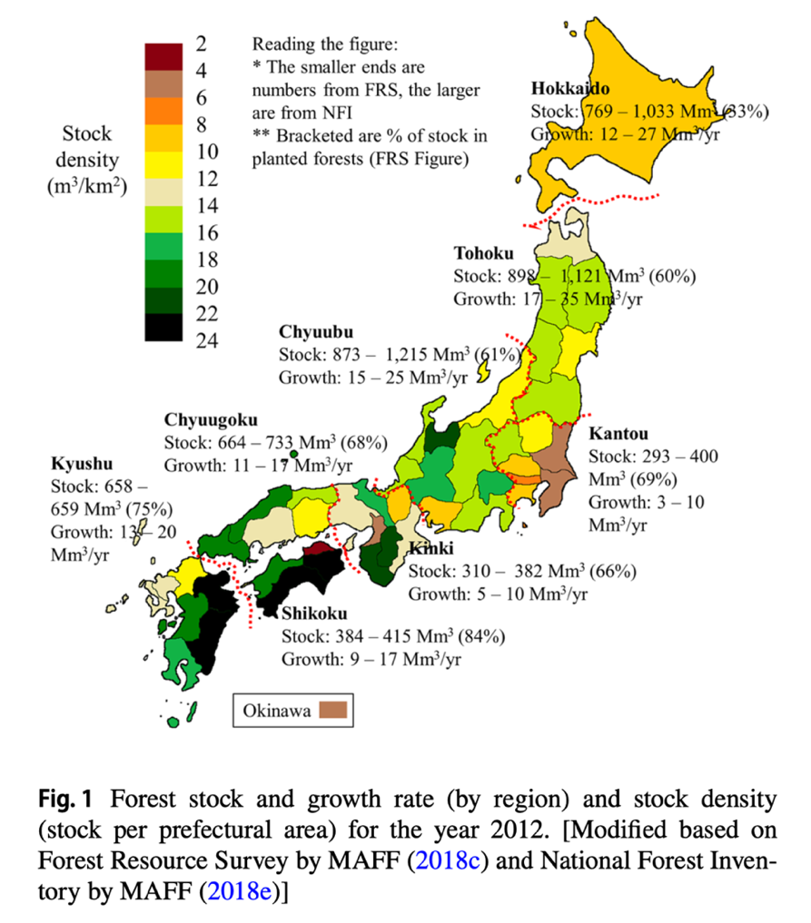

In Akita, over 55% of household electricity demand can potentially be met with local biomass (Goh et al., 2019). In fact, there has been an effort to use local forest biomass for a renewable energy source in Akita; United Renewable Energy company managed to build a 20MW capacity biomass power station in 2013. The plant is mainly fueled (70~80%) by low-value wooden biomass from local forestry, which was previously categorized as waste and unused (United Renewable Energy, n.d.). The project revitalized the local forestry by contracting long-term deal (20 year~) to supply the fuel needed; the long-term contracts support the local forestry substantially for financial and investment reasons. By building the power plant, they also managed to create new jobs such as manufacturing wood pellets, transporting the necessities, and managing the power plant. According to the company, 100 people have been newly employed for the operation (United Renewable Energy, n.d.). When depopulation is progressing in a rural area, these business models can prevent people from moving to a metropolis.

Offshore Wind Power

Japan has the sixth-largest exclusive economic zone in the world. Therefore, it is natural to think the potential of offshore wind power is vast; however, presently, there is no offshore wind farm operating along the coast. There are some reasons for retardation. The first reason is the island’s volcanic geography. Due to the steep continental shelf that Japan sits on top of, water depth quickly drops, and it exceeds the maximum depth limit to a bottom fixed offshore wind foundation. Currently, the maximum is set at 60m, so that offshore wind power development needs to take place within a relatively short distance to shore in Japan (NEDO, n.d.). Planning to develop offshore wind farms within 2km to shore is common, and that will be visible from the land, which brings to another problem of local opposition. In Akita, where private companies are planning to build offshore wind farms, there are local oppositions against the development due to health concern mainly about noise and also, complaining about the possible landscape deterioration (The Surf News, 2019). However, out of all opposition, perhaps the most controversial one is from fishermen communities. In Akita, fishermen are concerning that constructing windfarms would prevent local fish - Hatahata from coming to the ocean and lose their traditional way of living (秋田魁新報, 2019). Lastly, the capacities of assembly harbours are not sufficient to support the construction of offshore wind farms (Bloomberg 2020). As the Japanese coast is extensive in length and often the offshore wind development takes place away from the metropolis, large ports, which initially meant for international trading is not available. Therefore, by current policy scope, individual companies may theoretically construct the turbines; however, they will face issues in practice.

To overcome these hurdles, technological development, systems for bringing benefits to local stakeholders, and changes in the scope of national policies are necessary. First, a technological breakthrough is on the way by floating offshore wind turbines becoming viable . Floating offshore wind turbines can be built where water depth is up to 1000m, which opens vast new possibilities for Japan (fig.3) (Bloomberg, 2020). From 2009, the turbines’ cost has dropped 86%, and currently, pilot models are on the way, such as WindFloat Atlantic in Portugal with 24MW capacity (Bloomberg, 2020), and France aiming to build one by 2021 (EOLMED Project, n.d.). Bloomberg estimates that floating offshore costs will fall 56% more and eventually; it will only be 9% more expensive in the future compare to bottom-fixed wind power financed in 2019 (Bloomberg, 2020). Therefore, the possibility of offshore wind power in Japan will only enlarge, and policymakers should expand the scope into the future.

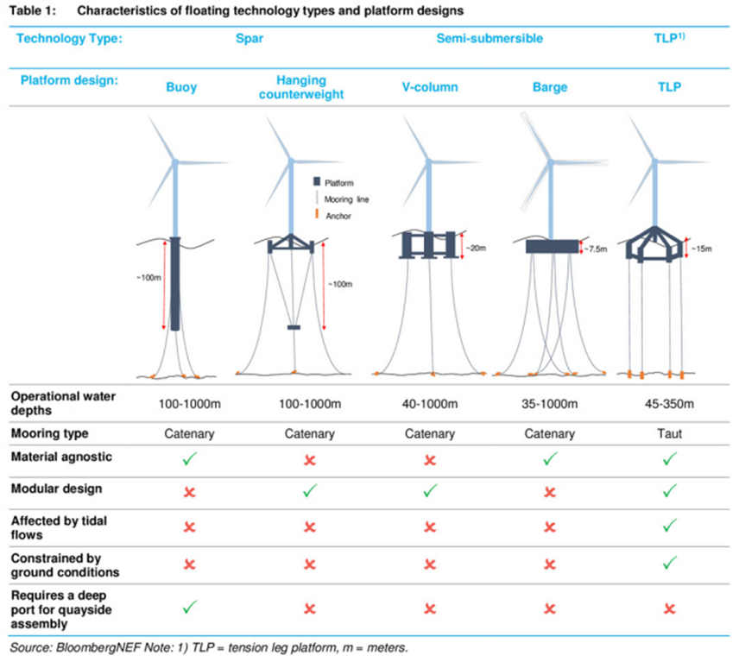

(fig.3)

Second, to bring back the idea of resilience, offshore wind power turbine structures might be excellent monitoring as well as refuge station for marine species, leading to better management of the ocean, contributing to achieving ecological and social resilience. By ensuring these two offshore wind power systems become relevant. Krone et al. studied the effect of installing offshore wind turbine foundations to marine megafaunas, using Cancer Pagurus as an example and model species (2017). The research was conducted in the North Sea two years after the deployment of offshore wind turbines (p.54). The study found out that in German Bight, where natural subtidal hard substrate structures are scarce, offshore wind turbine foundations are acting as an artificial reef, attracting megafaunas. For C. Pagurus, it serves as aggregation sites as well as nursery grounds, contributing to comprise 27% of local stock, and in the future, the structures would provide habitats for another 320% crabs (p.53). Although they acknowledge unpredictability and more longer-term implications, it elucidates that offshore wind foundations could act as a hosting site.

Moreover, Ashley et al. investigated the possibility of offshore windfarms to become marine protected areas (2014). In this study, they discovered the dominant trend, which indicates increased stock of substrata associated species, especially benthic bivalves, crustaceans and reef-associated fish; however, a decrease in algal abundance (p.301). Finally, they concluded that “potential benefits from designation of [offshore wind farms] as [marine protected areas] are apparent to both conservation and commercial fisheries but require dedicated monitoring at multiple sites and over longer time scale to increase confidence in the trends identified” (p.308). Therefore, marine monitoring technology needs to establish along the side of the development of offshore wind turbines. Luckily, there are vast possibilities for such technology to leap, especially with the advancement and implementation of AI. Professor Masahiro Nakao at the University of Tokyo is developing marine monitoring technology by employing the combination of AI and 5G (University of Tokyo, 2018). In November 2019, with help from a private corporation, he succeeded in the experiment to remotely control submarine drones to monitor oyster farms in Hiroshima prefecture (IT media Enterprise, 2019). These technologies can be applied on offshore wind turbines foundations as well, enhancing the monitoring of the submarine environment (fig.4). 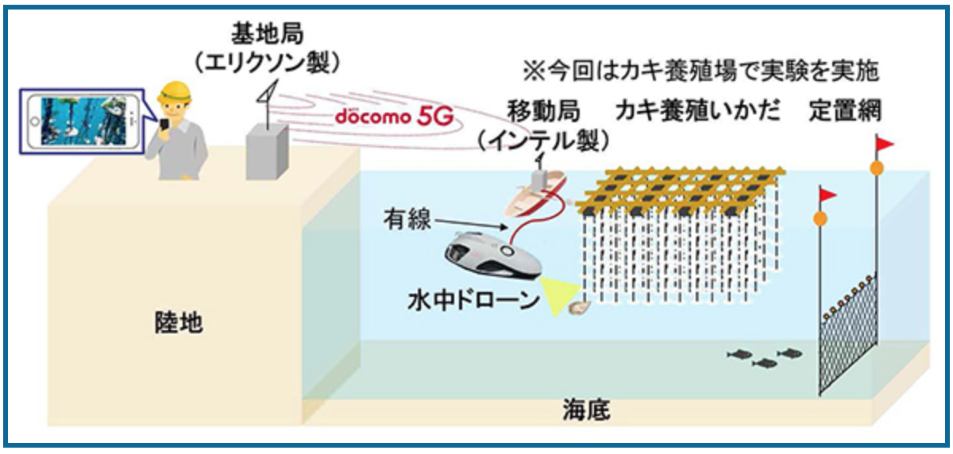

(fig.4)

Seaweed and CO2 Drawdown

Not only for the monitoring purpose, if floating offshore wind turbines become viable, along the catenary, but there could also be seaweed farms to enhance the carbon sequestration in the ocean. In the book *Sunlight and Seaweed, An Argument for How to Feed, Power and Clean Up the World*, Flannery states that the kelp can de-acidifies the seawater by removing carbon dioxide within the water at unconventionally first-rate, some people call this sequestration as blue carbon (Horne, 2018). This form of carbon sequestration is effective because the kelp grows 30 times faster than land plants and the products can turn into methane for generating electricity instead of using natural gas (Horne, 2018). Furthermore, it is known that oxygen that kelp provide will improve the aquatic conditions for fish and increases the stock (Horne, 2018). Therefore, by enlarging the scope of what offshore wind turbines ought to do, it can turn into a multi-purpose building for strengthening ecological and social resilience, furthermore, by incorporating the multifunctional role, social acceptance to building offshore wind turbine increases.

Energy Efficient Buildings and City

Lastly, I argue that switching energy sources from fossil fuels to renewable resources is not enough, but rather the building and city itself needs to be more energy-efficient, overall using less energy than now. There are many ways to accomplish this target, such as: designing Net Zero Energy buildings. Net Zero Energy buildings are those buildings that generate energy as much as their usage; they consume net-zero energy on a yearly basis (Shad, 2017). The idea of having those buildings and the innovations required for transformation are often neglected; however, they are the key to improve energy efficiency because residential use of electricity comprises approximately 30% of all electricity consumed in Japan. Therefore, if all residences become self-sustained, we can effectively cut 30% of the energy supply. Thinking house as a mere shelter made up of bricks and roof is archaic, the design needs to change. About 40% of households’ electricity is used for air conditioning in Japan, and especially it is higher for northern regions like Akita. If we can mitigate this amount by employing a ground-coupled heat exchanger system, coupled with solar panel and storage batteries, we can create a system that sustains itself. The ground-coupled heat exchanger system is used for Tokyo Sky Tree, and it brings a comfortable atmosphere in the clean way.

2076 words

Works Cited

Akita Prefecture Official Website. (2019, December 24th). *Population and Number of Households in Akita.* <https://www.pref.akita.lg.jp/pages/archive/9910>

Ashley, M. C., Mangi, S. C., & Rodwell, L. D. (2014). The potential of offshore windfarms to act as marine protected areas – A systematic review of current evidence.*Marine Policy, 45*, 301-309. doi:10.1016/j.marpol.2013.09.002

Bloomberg. *Floating Wind Farm Starts Generating Power Off Portugal’s Coast.* (2020, January 3rd).<https://www.bloomberg.com/news/articles/2020-01-03/floating-wind-farm-starts-generating-power-off-portugal-s-coast>

Goh, C. S., Aikawa, T., Ahl, A., Ito, K., Kayo, C., Kikuchi, Y., . . . Yamagata, Y. (2019). Rethinking sustainable bioenergy development in japan: Decentralised system supported by local forestry biomass.*Sustainability Science,*doi:10.1007/s11625-019-00734-4

Horne, E. (2018). *Sunlight and seaweed: An argument for how to feed, power and clean up the world [book review]*. Deakin: Australian Science Teachers Association. <http://web.b.ebscohost.com.ezproxy.library.ubc.ca/ehost/pdfviewer/pdfviewer?vid=1&sid=13f0dd07-78e6-4085-8996-9cc38506cafd%40pdc-v-sessmgr02>

Ideol.(2018.February 11th). *EOLMED Project.* <https://www.ideol-offshore.com/en/eolmed-project>

ITmedia Enterprise. *5G×水中ドローン”で沖合の養殖カキをリアルタイム監視　スマホで高画質映像を確認――NTTドコモと東京大学が実証.*(2019, November 29th). <https://www.itmedia.co.jp/enterprise/articles/1911/29/news057.html>

Krone, R., Dederer, G., Kanstinger, P., Krämer, P., Schneider, C., & Schmalenbach, I. (2017). Mobile demersal megafauna at common offshore wind turbine foundations in the german bight (north sea) two years after deployment - increased production rate of cancer pagurus.*Marine Environmental Research, 123*, 53-61. doi:10.1016/j.marenvres.2016.11.011

MHI Vestas Offshore (2019, October 22nd). *Wind First Turbine of WindFloat Atlantic Moves Into Position WindFloat Atlantic.* <http://www.mhivestasoffshore.com/first-turbine-of-windfloat-atlantic-moves-into-position/>

New Energy and Industrial Technology Development Organization. *NeoWins*. <http://app10.infoc.nedo.go.jp/Nedo_Webgis/index.html>

The University of Tokyo III and GS II. *AI/IoTを活用した「スマートかき養殖」の実証実験を開始-広島県の公募事業「ひろしまサンドボックス※1」に選定*-.(2018, December 13th). <http://www.iii.u-tokyo.ac.jp/news/201812139135>

The Surf News. (2018/10/05）*海上に約100本の巨大風車。秋田県の風力発電計画とサーファーの反対運動.* <https://www.surfnews.jp/news_topics/news/9744/>

United Renewable Energy Co,Ltd.(2015, October 10th). *Local Contribution and Economic Effect.* <http://www.united-re.jp/company/meaning>

Youtube, TEDx Talks, Shad David (2017, December 8th). Buildings of the Future: Net Zero Energy. <https://www.youtube.com/watch?v=bi-Zu09vX3o&t=513s>

秋田魁新報. (2019, October 22nd)*由利本荘市沖・洋上風力計画説明会　健康被害、懸念の声　相次ぐ反対、賛成意見も*. <https://www.sakigake.jp/news/article/20191022AK0002/>

秋田魁新報. (2019, October 9th). *洋上風力促進区域　国指定へ、法定協開催　全国初、本県沖２区域で議論*. <https://www.sakigake.jp/news/article/20191008AK0025/>